Performance Test Report

**Test #2:** Run NetworkX scripts on Cassandra database to update staging database

**Prerequisite:** Server should be turned off at least 3 hours before test

**Results:** NetworkX scripts were run impact was recorded for a period of one hour.

**Performance Stats:**

CPU impact:

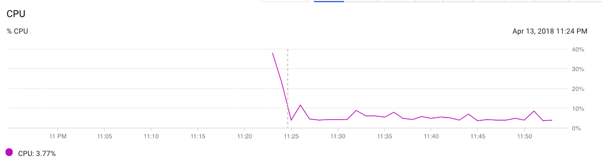

Network Impact:

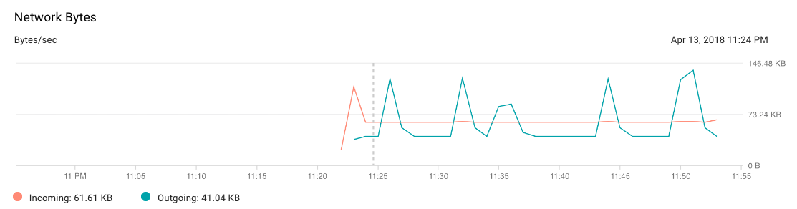

Network Packets impact:

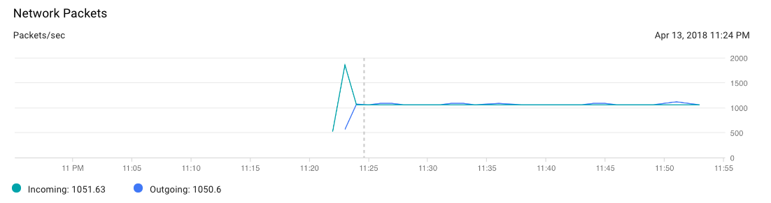

Bytes spent on I/O:

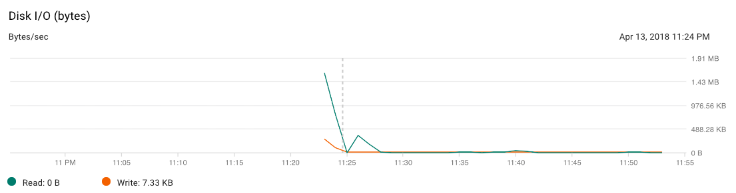

**Outcome:**

The highest CPU usage was 38% when NetworkX scripts were run and data was retrieved from Cassandra DB. This was still less than our threshold of 60% when the system admin is notified.

Also 173 worth of outgoing network packets were shared which is normal behavior and does not impact cloud server.

Incoming Network packets were 1851 in number which is quite high and we would be creating a task to look into the issue in next Sprint.

**Next Steps:**

Create task to triage high incoming network packets issue